**Exercise 1 - Use a deployment to deploy MySQL on minikube cluster #**

***To complete this exercise you have to deploy MySQL on Kubernetes, using a template file (yaml), with the following characteristics:***

***- Deploy a MySQL instance on your Kubernetes cluster in a single pod using deployment.***

***- The MySQL server shall have a database named "sample".***

***- Your instance shall have a user names *mysql* with *mysql* as the password.***

***- You shall be able to access your instance from outside of the cluster with MySQL client on your host machine.***

***\*\*Note**: You are not expected to use persistent volumes nor managing the secrets.***

***<u>**Assessment**</u>: Connect to MySQL with mysql client utility from host machine and verify that the connection works***

***source :******<https://kubernetes.io/docs/tasks/run-application/run-single-instance-stateful-application/>***

***mysql-deployment.yml :***

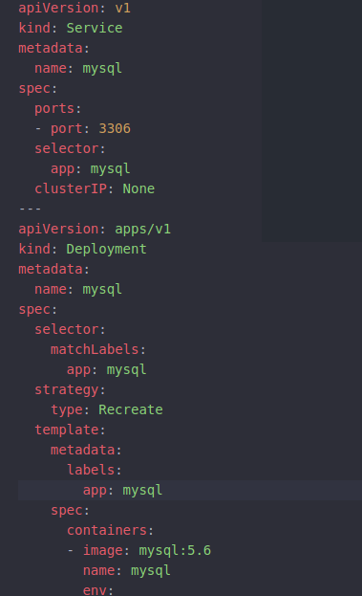

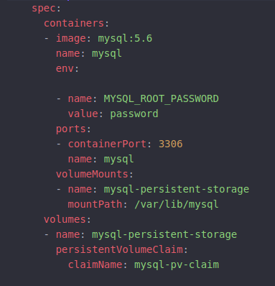



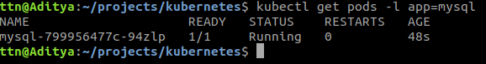

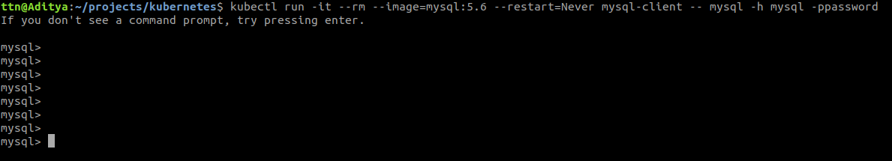

**Exercise 2 - Adding secrets for MySQL in POD #**

***This exercise is about using a password for the MySQL database that is not exposed in the yaml file describing the application. You will modify the file that you have created during the first exercise and change how the password is passed to the MySQL container:***

***- You have two options to achieve this lab. Select the one that you prefer. (Create secret using command line or file)***

***- The password shall not appear in the file describing the application.***

***\*\*Note**: You are not expected to use persistent volumes.***

***<u>**Assessment**</u>: Connect to MySQL with the password used in secret.***



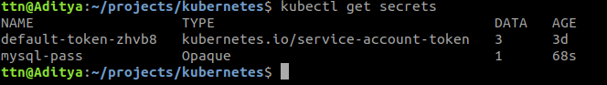

**Exercise 3 - Adding wordpress to the deployment #**

***In this exercise you are asked to deploy Wordpress on your Kubernetes cluster. This deployment of Wordpress shall use the MySQL deployment that you have done in the previous exercises and the website shall be resilient to container outages should they happen.***

***At the end of this exercise, you must be able to connect to your wordpress website and create your blog. If you delete or restart the wordpress container the website shoud come back up as it was before the operation.***

***\*\*Note**: You can change the mysql service type created in previous exercises for this exercise.***

***<u>**Assessment**</u>: Connect to your WordPress deployment and verify that you can create a website.***



